To understand which restaurant types thrive in high-income areas, we analyzed the relationship between restaurant price levels and ZIP code-level demographic indicators, using the population aged 45 to 64 as a proxy for wealth. This age group is commonly associated with higher earning potential and financial stability, making it a useful indicator of affluence. Our analysis revealed that restaurants classified as price level 2 (moderately priced) were most prevalent in ZIP codes with a higher concentration of this demographic. This suggests that mid-range restaurants are particularly successful in affluent areas, potentially due to their balance of quality and value. Interestingly, price level 1 (budget-friendly) restaurants also showed a strong presence in these areas, which may reflect demand for casual, convenient dining options regardless of income. In contrast, higher-end restaurants (price levels 3 and 4) were less concentrated in high-income areas, possibly due to their more niche appeal or limited customer base. These findings suggest that while affluence can support premium dining, a diverse mix of restaurant types—including mid-range and budget options—tends to thrive in wealthier communities.

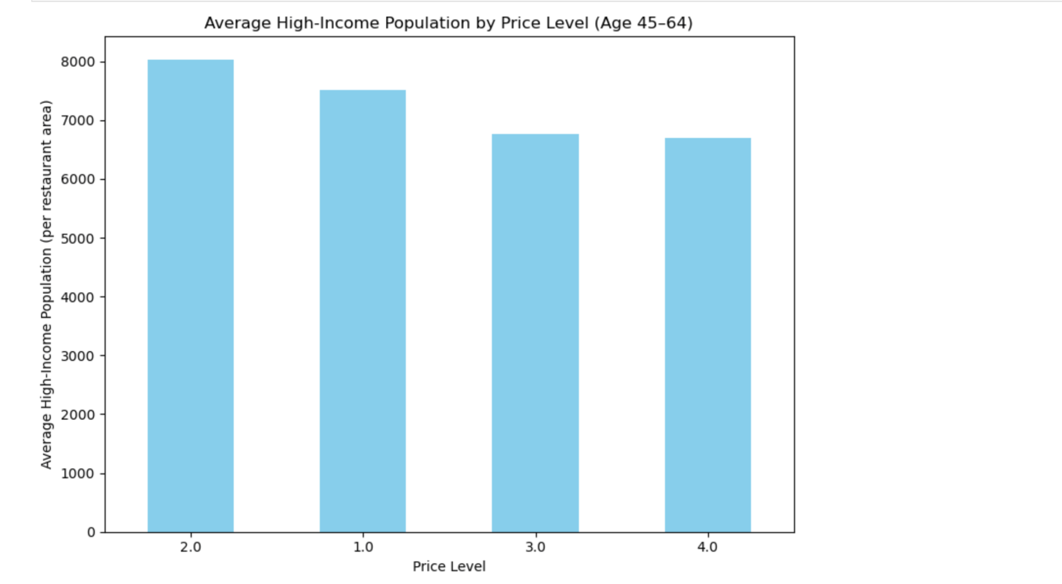

1. Based on the filtered dataset excluding the dominant "Other" category, the plot reveals which cuisines are overrepresented within individual zip codes that host more than five restaurants. American cuisine stands out as the most consistently overrepresented across several zip codes, suggesting it is often a leading choice in local markets. Asian and Italian cuisines also appear prominently, each being highly concentrated in select zip codes, indicating localized popularity or cultural enclaves. The absence of other global cuisines in the top results—due to their classification under "Other"—highlights the need for finer-grained classification to fully capture culinary diversity. This analysis underscores how specific cuisine types can dominate neighborhood food landscapes, and suggests potential areas for expansion or diversification in underserved areas.

